Q’s for T and D needed.
12/14/2018

The Range of Rhetoric
Rhetoric and Communication
Theory and Practice
Kenneth Burke on Dilemmas
Dilemmatics
Add onFake news
Billig and Protagoras
Preview of Chapters
Summary
Exercise for Thought and Discussion
We better understand, practice, and critically analyze politics when we can anticipate its dilemmas, are aware of the pushes and pulls that give rise to them, and are strategically savvy in coping with them. How that proposition bears on various political contexts--e.g. electoral politics in the U.S., struggles for dominance in Egypt—is what this book is about. Presented in the book is a dilemma-centered, integrative approach to political persuasion. It comes to you at an epoch-changing preriod in American politics involving the rise and fall—or decline—of President -Donald Trump.
Politics

The Merriam-Webster online dictionary variously defines politics as the (1) art or science of government, (2) actions that relate to influencing the actions and policies of a government, (3) getting and keeping power in a government, (4) the work or job of people who are in a government, and (5) political actions, practices, or policies.
More generally, politics is about conflict and collaboration, power and influence where rhetoric in its many senses of the term plays a central role. Politics enters into controversies when interests are at stake and governments are involved, if only obliquely. Where there is politics there is persuasion, aimed at seizing opportunities, meeting challenges, and thus realizing interests.
Rhetoric as Inquiry and Advocacy
Most neutrally, rhetoric is the theory, practice and critical analysis of persuasion, used in coming to judgments (i.e., self-persuasion) and in bringing others to those judgments. It operates in the vast spaces between definitely Yes and assuredly No: the region of surmise rather than certainty, of what is wise or unwise, prudent or imprudent, plausible or implausible, probable or improbable.
Where there is politics there is persuasion, aimed at seizing opportunities, meeting challenges, and thus realizing interests.

Plato “Versus” the Sophists
Today’s practice of persuasion is mired in controversies that mirror those in ancient Greece almost 2,500 years ago, and they are unlikely to go away any time soon. At issue still are questions of truth, justice, ethics and power reflected in seemingly endless disputes. These disputes find clear expression in those of Plato’s scripted Socratic dialogues wherein Socrates enters into conversation with various sophists of his day. (Plato, Trans. Helmbold, 1952) In Gorgias Socrates elicits self-damning boasts by Gorgias and his fellow sophists that by offering instruction to their students in how to create deceptive appearances, the students can achieve greater power than those of the experts they pretend to be. Is this con artistry? Gorgias would have preferred a eulogistic appellative, one that encompassed today’s advertising and public relations. When used disparagingly, as in Plato’s Gorgias, “rhetoric” evokes images of triviality and worse: of manner rather than matter, style rather than substance; appearance rather than reality, fallacious reasoning rather than sound reasoning, of gulling people by way of trickery and deception, and of bombast, exhibitionism, ingratiation and decoration. The general term for manipulations of these sorts is “sophistry” and it is generally held in low esteem even by those whose roles in political life may require them to practice what they privately deplore.
Drawing on Lanham (??), literary theorist Stanley Fish contrasts “rhetorical man” –homo rhetoricus—from “serious” man (homo seriosis) the former more playful, imaginative, witty, and, as the term suggests, sophisticated, more willing than seriosis to entertain new ideas but perhaps less rigorous in testing them for accuracy or predictability. Good arguments, then, can be made for both. ?Kennedy (date?), a classics rhetorician, defends both as two fundamental differences in viewing the world. (See also Billig on “witcraft.” (1987)). Said Fish (1989) For rhetorical man the distinctions invoked by serious man are nothing more than the scaffolding of the theater of seriousness, are themselves instances of what they oppose. And on the other side, if serious man were to hear that argument, he would regard it as one more example of rhetorical manipulation and sleight of
hand....And so it has gone; the history of Western thought could be written as the history of this quarrel.
Stanley Fish (1989), "Rhetoric," p. 484
(Double space needed)
For a contemporary dialogue with parallels to the Gorgias, here is an excerpt from The Daily Show of former host Jon Stewart doggedly pursuing CNBC’s Jim Cramer in 2005 at the height of the worldwide financial meltdown. When used disparagingly, as in Plato’s Gorgias, “rhetoric” evokes images of triviality and worse: of manner rather than matter, style rather than substance; appearance rather than reality, fallacious reasoning rather than sound reasoning, of gulling people by way of trickery and deception, and of bombast, exhibitionism, ingratiation and decoration. The general term for manipulations of these sorts is “sophistry” and it is generally held in low esteem even by those whose roles in political life may require them to practice what they privately deplore.
Rhetoric without that dispute is the modern day social psychology of persuasion, concerned with communication variables and their effects on audiences. Rhetoric with that dispute is about the history of ideas and the life of the mind. The dispute is ongoing as illustrated in this televised exchange between former Today Show host, John Stewart, and MSNBC guru, Jim Cramer, in the aftermath of the worldwide financial meltdown.
STEWART: …This is the promo for your show.
-"In Cramer We Trust” promo” plays-
STEWART: …Isn’t there a problem with selling snake oil and labeling it as vitamin tonic and saying that it cures impetigo... Isn’t that the difficulty here?
CRAMER: I think that there are two kinds of people. People come out and make good calls and bad calls that are financial professionals and there are people who say they only make good calls and they are liars. I try really hard to make as many good calls as I can.
STEWART: I think the difference is not good call/bad call. The difference is real market and unreal market. Let me show you…This is…you ran a hedge fund.
CRAMER: Yes I did.
-2006 video of Jim Cramer being interviewed on TheStreet.com-
CRAMER: You know a lot of times when I was short at my hedge fund and I was position short, meaning I needed it down, I would create a level of activity beforehand that could drive the futures. It doesn’t take much money.
-End video-
STEWART: What does that mean?
CRAMER: I have been trying to reign in short selling, trying to expose what really happens. This is what goes on, what I’m trying to say is, I didn’t do this but I’m trying to explain to people this is the shenanigans that—
STEWART: Well, it sounded as if you were talking about that you had done it.
CRAMER: Then I was inarticulate because I di--I barely traded the futures. Let me say this: I am trying to expose this stuff. Exactly what you guys do and I am trying to get the regulators to look at it.
STEWART: That’s very interesting because, roll 210.
-210 video-
CRAMER: I would encourage anyone who is in the hedge fund unit to ‘do it’ because it is legal. It is a very quick way to make the money and very satisfying. By the way, no one else in the world would ever admit that but I don't care.
UNKNOWN: That’s right and you can say that here.
CRAMER: I’m not going to say it on TV.
-End video-
-Audience groans-
CRAMER: It’s on TV now.
STEWART: I want the Jim Cramer on CNBC to protect me from that Jim Cramer.

The Range of Rhetoric (formatting needed)
Opinions differ as to whether rhetoric is exclusively

evidence and argument, or includes “extra-factual,” “extra-logical”

dimensions to accomplish its ends. (Gaonkar, 1990).

“Enlightenment” thinkers relegated rhetoric to the

role of step-sister to philosophy, and other critics

sought to banish it or “cleanse” it ever since, but this

has not stopped them from using its tools. No less a

philosopher than John Locke used metaphor in his condemnation

of metaphor, calling it a “perfect cheat.” The general point is that

truth does not stand on its own two legs. The facts on which

conclusions are drawn require interpretation (McCloskey. 1985;

Sanders, 1990) and interpretation is necessarily a matter

of judgment rather than algorithmic calculation. On this

view, rhetoric includes such “supplements” to a persuasive case as

issue framing, style, voice, ethos, pathos, word selection,

organization of ideas, and self-presentation. Together these

features of everyday discourse come to us as packages, exhibiting the

clarity and coherence of argument and evidence plus!

Such matters as a persuader’s style and self-presentation are

often dismissed as irrelevant to a case, but, as anthropologist

Clifford Geertz (1982) argued,

The strange idea that reality has an idiom in which it

prefers to be described, that its very idea demands we

talk about it without fuss, stems from a confusion,

traceable to Plato, of the fictional with the false:

making things out with making things up. Once we

recognize that texts are made, and made to persuade,

those who made them have more to answer for.” (p.9.

In his defense, Plato did not doubt the potential

power of rhetoric; what concerned him were the ethics

of its means and the ends to which they could be put.

Over the millennia rhetoric has meant many things, but

its general range of meanings and associations with it offer

small comfort to its defenders, not least tricksterism,

bombast, puffery, flattery, deception, chicanery, and making the

worse appear the better reason. If nothing else, this list is of

value for purposes of critical analysis. It should alert us

to the non-obvious, sinister uses of rhetoric in which meanings,

methods and motives are
masked . For rhetorical man the distinctions invoked by serious man are nothing
more than the scaffolding of the theater of seriousness, are themselves instances of what they oppose. And on the other side, if serious man were to hear that argument, he would regard it as one more example of rhetorical manipulation and sleight of
hand....And so it has gone; the history of Western thought could be written as the
history of this quarrel.
Stanley Fish (1989), "Rhetoric," p. 484 (formatting needed

Note to MSP: the following is interesting but not essential.
As a general rule, says Carolyn Miller,

rhetoric hides its tools (January, 2017?).

==== ------------------------------------------needs formatting
And needs cutting to include 7-10 slides, preferably, Foucault, Aristotle, Socrates, Cicero, Marlin Brando on Julius Caessar, History of the Royal Society, and the cartoons.

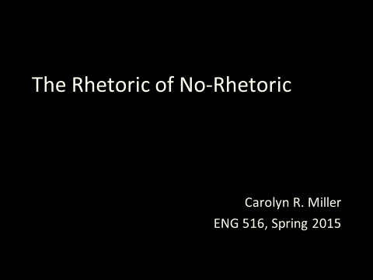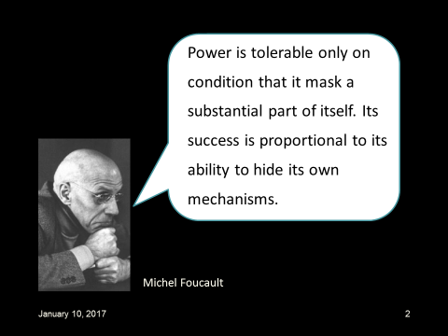

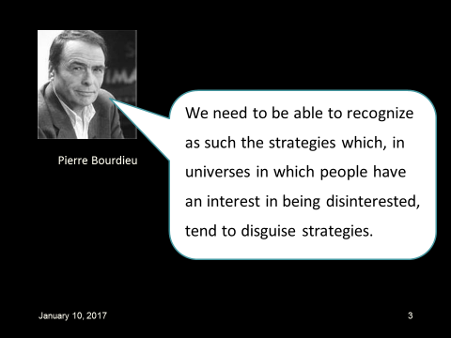

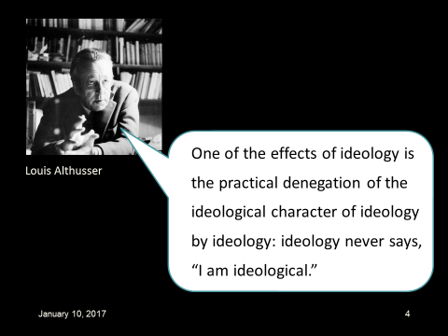

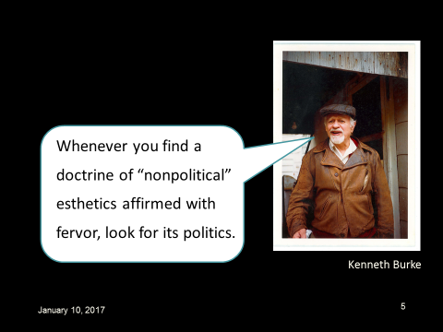

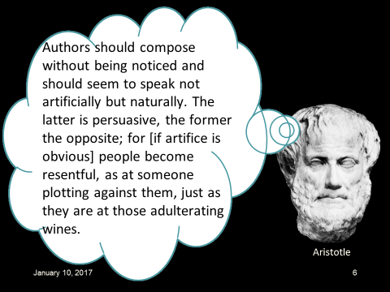

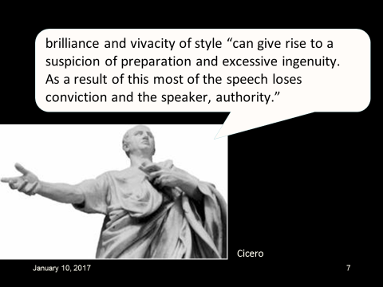

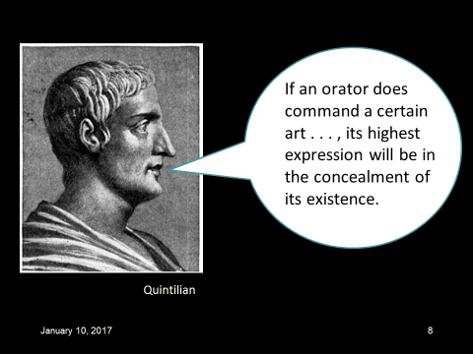

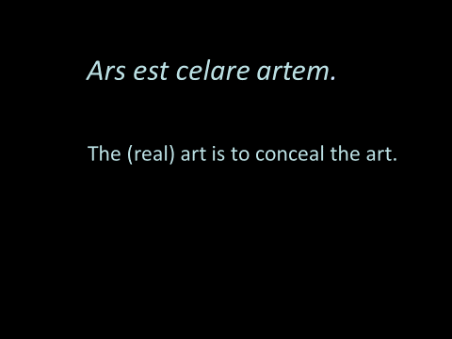

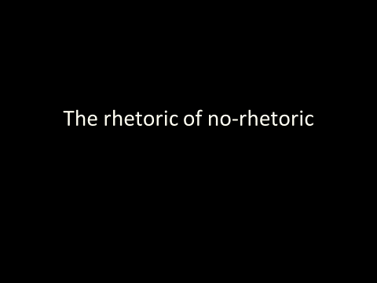

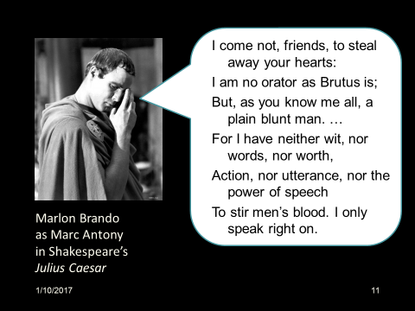

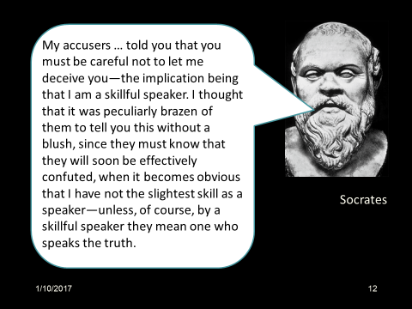

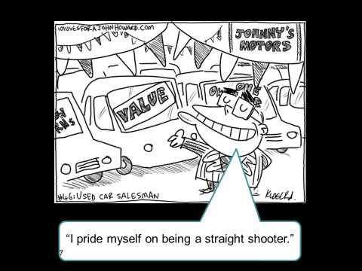

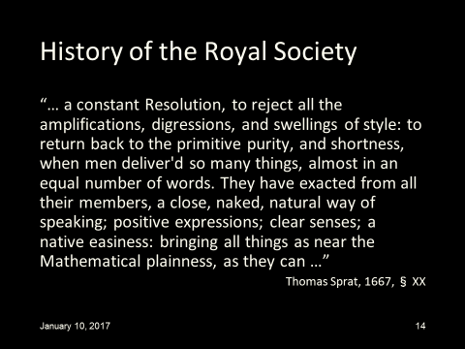

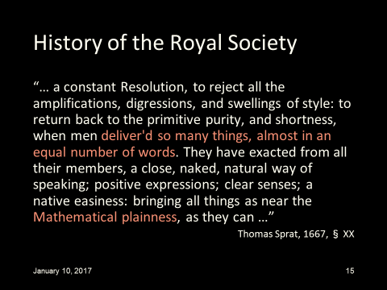

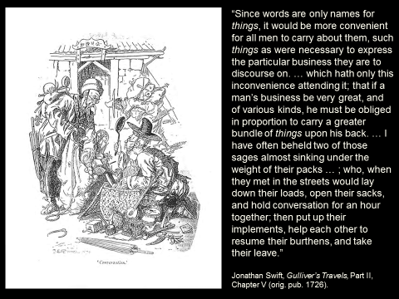

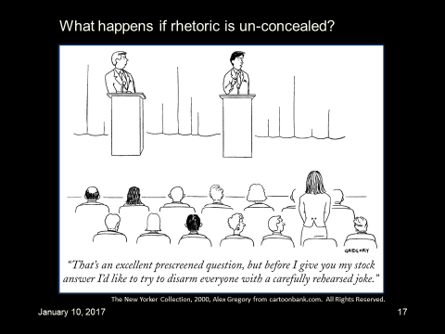

Fleshing out the ties between rhetoric and persuasion a bit

more, rhetoric is the form that discourse takes when it “goes

public”; that is, when it has been geared to an

audience, readied for an occasion, adapted to its ends.

On this view, rhetoric is not exclusively “hard” fact or, “cold”

logic, though it need not be false to fact or illogical.

As a mode of coming to judgment and of persuasion, rhetoric is well suited for dealing with what Herbert A. Simon (1967) called ill-structured problems, of the sort confronting political actors. These by definition are not amenable to solution by the application of technical rules. They thus beg the question for theorists of what choices are rational, especially given that emotions tend to run high and conflict is a given in matters political.
Under the circumstances, it makes little sense to speak of political policy advocates as proving their cases beyond the shadow of a doubt. What constitutes “proof” varies from situation to situation and from audience to audience. Similarly, it makes little sense to think of persuasive arguments as definitive or compelling.
Dilemmatics
The rhetorical study of dilemmas is concerned with their kinds and consequences, the factors giving rise to them and the tools of persuasion available in coping with them

Dilemma-centered discourse analysis identifies “push-pull” tensions in ideologies (e.g. authoritarianism vs. egalitarianism), leadership role conflicts (e.g., forgiveness versus blame), crisis rhetoric in times of war, and in such commonplace types of rhetoric—called genre—as the political apologia and the political eulogy (see Chapter 2).
Not uncommonly, strategies of influence aimed at ameliorating some dilemmas create others that make the problems worse. The post-9/11 U.S. invasions and occupations of Iraq and Afghanistan (Chapter 11), have exhibited these patterns and they have been aided and abetted by an echoing press), willing, at least initially, to respond uncritically to war hawks’ crisis rhetoric. (Simons, 2008).

Kenneth Burke on Dilemmas .
Over the course of an incredibly long and productive career, Burke (1897-1993) examined the ways of that most complex of all species: the “symbol-using, symbol mis-using animal” (Burke, 1966).
Burke said of political rhetoric that it “must lead us through the Scramble, the flurries and flare-ups of the Human Barnyard, the Give and Take, the wavering line of pressure and counter pressure, the War of Nerves, the War.” (Burke, 1969) But Burke reminded us that while rhetoric is often aimed at gaining advantages at the expense of others its “endless competition can add up to the transcending of itself. In ways of its own it can move from the factional to the universal.” Enemies can agree to reconcile; warring parties may agree that persuasion is preferable to guns. Burke also warns that the appearance of cooperation can serve as a partisan weapon.”(Burke, 1969) In Burke’s writings on political rhetoric one sees repeated evidence of the mixed-motive character of social life: the need simultaneously or sequentially to compete and cooperate with others. Identification with others is, as Burke puts it, “compensatory toward division” as when political activists unite to overthrow a dictator. In these moments, division gives way to collective action. But coalitions, such as united fronts, often give way to fragmentation. What was “a part of” becomes “apart from.”(Burke, 1969 G of M – Dialectics in General)
Just such a process of fragmentation occurred in Egypt in 2011 following the overthrow of the autocratic Mubarak regime, and for reasons that a prescient rhetorical theorist like Burke could have anticipated. Having been much moved by the Egyptian liberation movement I headed to its epicentre in Cairo during spring break from my teaching that semester at the University of Pennsylvania. Besides celebrating with the activists in Cairo’s Tahrir Square, I wanted to test what I thought I knew about social movements and responses to them by various political actors against the realities of Egypt’s revolution in the making.
That week the liberal-left activists I interviewed radiated confidence. They had deposed a dictator, been backed by the military, turned back security police who sought to disrupt the protests, and made common cause with the previous regime’s enemies, not least the Muslim Brotherhood. But a year later when I returned to Cairo the activists’ rosy glow had paled considerably. Once confident political activists were now uncertain as to whether they could trust Egypt’s current military leadership, doubtful as to whether they could continue to make common cause with the Muslim Brotherhood, at loggerheads over ideological differences within their own group, in disagreement about who should lead them and about how to forge lasting alignments.
Their dilemmas were understandable. In the early going, said Burke, revolutionaries “clamp limitations on themselves,” presenting to the world a united front. But soon the fissures arise as reality intrudes. Grand ambitions give way to hopes for more modest reforms. Elements of the old order regroup. Those in new positions of power begin to act like those they replaced. There is, said Burke, a ‘bureaucratization of the imaginative’ as those in power return to their old ways. Progress becomes more difficult to define. (Burke 1969/1950), Griffin, 1969).
The sequence of steps Burke identified fit together all too well as an archetypal narrative of revolutionary efforts like those in Egypt (discussed in Chapter 10) which have seen a return to power of the old order.
Burke’s account of failed revolutionary movements fits well with Egyptian revolutionaries’ dashed hopes, their consequent fragmentation, new opportunities, rebirths and renewed struggles to triumph over adversity.
The examples presented in this book include several instances of successful dilemma management. Martin Luther King’s civil rights movement dealt effectively with what for most protest leaders has been an intractable dilemma: that of combining power with love by way of a strategic integration of militancy and moderacy, here called the intermediate approach. (Chapter 4)
Implicated here are a society’s seemingly opposed values, as expressed in such aphorisms as “Never ventured, never gained” and “Better safe than sorry.”
Michael Billig suggests that aphorisms are gateways to the mind and to our shared ideologies, by which we use arguments in our thinking to wrestle with dilemma-laden issues, as between right to life and right to choose, authority versus equality, trust versus suspicion. The possibilities for arguing on a given issue are learned contextually by way of shared histories and our everyday experiences, from which we further develop our tools of thought.

For purposes of dilemma-centered analysis, the book finds kinship with colleagues who locate their source in ideological conflicts (e.g., Billig, et al., 1988; Jasper, 2006, Tilly and Tarrow, 2007) and in the everyday paradoxes and contradictions of human relations which, say Baxter and Montgomery (1996) shoudn’t be “smoothed out.” See also Fairhurst, 2010, Grint, date?, Poole & ???, date, Rice and Cooper, 2010; Rawlins, 1992; and Rittell and Webber, date?, ]
Michael Billig, a social psychologist recently retired from Loughborough University in the UK has been my other constant companion. photo of Michael Billig about here. See for example, our edited conference volume, Beyond Postmodernism. (Simons and Billig, 1994). On issues such as abortion Billig urges his readers to entertain the possibility of there being more than one common sense. This is reflected in such seemingly opposed aphorisms as “Many hands make light work” and “Too many cooks spoil the broth”; “Better safe than sorry” and “Never ventured, never gained.”
To his psychologist colleagues Billig suggests that if one psychological principle appears reasonable, they should try reversing it to see whether its contrary is just as reasonable” (Billig, 1996, p. 410) Readers might test their own fervently held principles with the same test of reversal.
Billig credits the sophist Protagoras with tests of this kind, their underlying premise being that there is always something to be said, pro or con, in a policy dispute or by the prosecution and the defense in the courtroom. In the Talmudic tradition, he has used as his own models of rhetorical practice seemingly unsolvable, well-argued disputes. Just because two people disagree does not mean that at least one of them must be committing a fallacy i.e., an error in reasoning. Here is an example:
In ancient Judea, so the story goes, the Jewish elders were challenged in their opposition to idolatry by some unnamed, but presumably Roman, idol worshippers. A Roman asks the first question: “Why, if God so opposes idolatry, doesn’t he destroy all the idols?” The elders ponder this tough question but then reply, “God would certainly do just that, if the idolators only worshipped useless objects. But the idolaters also worship necessary objects like the sun, moon, stars, and planets. Destroying these would put an end to God’s whole creation. Shall He then make an end of His world because of fools?” The Romans are not satisfied. They counter the argument with one of their own: “If God does not want to destroy the world, then let Him destroy only the useless idols.”
But this clever retort does not satisfy the Jewish elders. They answer the Romans with a question of their own: “If God destroyed your useless idols, but kept the moon, sun, stars, and planets, you would say these are the true deities because they had been untouched by the destruction of the idols” (Billig, 1996, pp. 130-131).

End of Box P.1
Summary

As typified by the cases it takes up, this book is distinctive for its approach to understanding, analyzing and practicing political persuasion. Burke’s take is on the “push-pulls” of confronting power by way of collective political action. He illustrates their futility but captures well the oppositions between protest activism and agents of social control. Like Burke Political Persuasion moves between theory and practice, one case and another, this for purposes of discourse analysis and for generalizing about factors impelling and constraining rhetorical choice.
The book’s stock characters, seen by Kennedy as irreconcilable ways of philosophizing about discourse, are Homo seriosis and homo rhetoricus. Rhetoric involves both coming to judgment and bringing others to those judgments. The general point is that truth does not stand on its own two legs. The facts on which its conclusions are drawn require interpretation which is necessarily a matter of judgment rather than algorithmic calculation. It includes such

“supplements” to a persuasive case as issue framing, style, voice,

ethos, pathos, word selection, organization of ideas, and self-presentation. Together these features

of everyday discourse come to us as packages, exhibiting the clarity and coherence of argument

and evidence plus!

For purposes of dilemma-centered analysis, the book finds kinship with colleagues who locate their source in ideological conflicts (e.g., Billig, et al., 1988; Jasper, 2006, Tilly and Tarrow, 2007) and in the everyday paradoxes and contradictions of human relations which, say Baxter & Montgomery (1996) shoudn’t be “smoothed out.”
Preview of Chapters
Chapters 1-3, together with this preface, provides key concepts, cases and controversies. Chapter 1 offers a “Top Ten” list of predictable predicaments and another list of common strategies. Chapter 2 also introduces readers to my co-active approach to persuasion and Chapter 3 defines and illustrates dysfunctional political systems. The middle chapters deal with campaigns and movements, deliberation and governance. Chapters 8-11 in Part 3 provide rhetorical histories and Chapter 12 wraps things up.
Chapter 1 builds on the case made here for a dilemma-centered perspective, introduces my “RPS” approach to the study of social movements (Simons, 1970) and illustrates its possibilities for theoretical extension as in the analysis, with Xing Lu, of the Chinese Communist Party’s (CCP) transitional rhetoric. (Lu and Simons, 2006) The CCP’s “top-down” rhetoric is analyzed in Chapter 9.
Chapter 2 uses case studies and commentaries to illustrate key concepts and methods for critical analysis. Among the chapter’s key concepts are rhetorical genre, core dilemmas, core strategies, as-a-rule rules, theory, systems and retrospection.
On the analogies to unwanted, repetitive, dysfunctional behavior by individuals and business organizations (Cronen, 1982, Rice and Cooper, 2010) Chapter 3 puts forward what will likely be regarded as this book’s most controversial concept, that of dysfunctional political systems. The analogy is Singer’s (1980), as applied to organizational dynamics. I also argue that dysfunctional political systems are mired in contradictions, as when efforts by the U.S. at winning friends in Iraq, Afghanistan and elsewhere in Asia are repeatedly undermined by news of their own drone attacks killing innocent civilians and other news of cozy political alliances with despotic regimes. Rather than enhancing America’s image abroad news of this kind is bound to exacerbate antagonisms. But there is no easy way out of the dilemma, suggesting that the problem is systemic.
Chapter 4 develops further this book’s “RPS” approach to the study of social movements and reviews other contributions to this vast and growing literature from rhetorical studies and sociology. Its analyses of social movement rhetoric are as much interested in situational determinants of rhetorical choice as in the choices themselves.
Political Persuasion relies considerably on sociological and organizational theory – too much so, according to my critics. More conference time than I care to remember has been spent in “chicken-egg” disputes with my rhetorician colleagues over such issues as whether movements create rhetoric or rhetoric creates movements.
Chapter 5 presents and applies a model of campaign stages and components, its examples including a long-term campaign to end clitoral mutilation in Senegal, support for the humane treatment of animals being readied for slaughter, and a carefully designed effort in Salina Kansas and other prairie towns to enlist help in renewable energy projects. Readers are urged to apply the model in analyzing campaigns of their own choosing.
Chapter 6 provides a tongue-in-cheek Machiavellian guide to political campaigning. Readers are introduced to the “new, new” politics, it’s main competitors typically awash in unrestricted campaign funds.
Chapter 7, on deliberation and governance, identifies dilemmas facing policy makers under current conditions of extreme polarization, wherein the practice of “sabotaging” much needed legislation is seen as preferable to handing one’s political opponents a victory. Drawing on Edsall and Edsall (1991) their book traces the sharp divide between liberals and conservatives in the United States to the backlash against the movements and riots of the sixties. It then shifts to questions about how to deliberate.
Chapter 8 is on what came to be called the “Barbiegate” controversy after word spread that school officials in progressively liberal Boulder, Colorado had taken down a poster board summary of a third grader’s Science Fair project on children’s and adult’s preferences for a white or black Barbie, clad in either a white or lavender dress.
Chapters 9-11 take up, respectively, China, Egypt, and, following “9/11,” Wars and Media, including those in Iraq and Afghanistan.
Chapter 12 looks back at the preceding chapters, and then ahead in concluding the book with Lessons Learned. Highlighted there are pervasive themes: about money and power, rationality and irrationality, ideology and contradiction, persuasion and its limits. The Appendix takes up more recent issues.
As should by now be apparent I do not view the study of rhetoric as the exclusive preserve of self-styled rhetoricians. Nor are contributions to its study necessarily labeled as such. By whatever name—e.g., argumentation, statecraft, impression management, frame alignment, public diplomacy—they are worthy of attention as long as they advance our understanding, practice and analysis of political persuasion.

Works Cited
Baxter, L. and Montgomery, B. (1996). Relational Dialectics. New York: Guilford.
Billig, M. (1996) Arguing and Thinking: A Rhetorical Approach to Social Psychology. 2nd ed., Cambridge: Cambridge UP.
Burke, K. (1969/19??) A Rhetoric of Motives. Berkeley: University of California Press.
_____ (1969/19??) A Grammar of Motives. Berkeley: University of California Press.
Cronen, et al(1982) Paradoxes, double-binds and reflexive loops. Family Process, 20, 91-112.
Edsall, T. (2004??) The Age of Austerity: How Scarcity Will Remake American Politics. NY: Doubleday
Edsall, T. & Edsall, M. (1991) Chain Reaction (New York:Pub?)
Edsall, T. (nov,/7/11) The future of the Obama coalition. New York Times.
Edsall 1dec5/11 The Reinvention of Political morality. Edsall 11/27/11 Democrats will officially abandon the white working class, New York Times
Fairhurst, G. (2010) The Power of Framing: Creating a Language of Leadership. NY: Wiley & Sons.

Gaonkar, G.P. (1990), Rhetoric and its Double. In H. Simons, ed. The Rhetorical Turn. Chicago: UCP.
Griffin, L. (1969) A dramatistic theory of the rhetoric of movements.In Rueckert, ?, Ed. Critical Responses to Kenneth Burke. Minneapolis: University of Minnesota Press

Leff, 1989. Modern sophistic. In Nelson, J, Megill, A, and Mccloskey, M.N.(eds) The Rhetoric of the Human Sciences. Madison: U. of Wisconin Ptrss.
Lu, X. and Simons, H.W. (2006) Transitional rhetoric of China’s Communist Party leaders in the post-Mao reform period: dilemmas and strategies, Quarterly Journal of Speech, 92, 3, 262-268.

Helmbold, ? Kennedy?
Miller, C.. [check title]Should we name the tools? Revealing and Concealing the Art of Rhetoric. In D. Coogan and J. Ackerman , eds. Columbia SC: USC Press
Rice, R.E. and Cooper,, S.D. (2010) Organizations and Unusual Routines: A Systems Analysis of Dysfunctional Feedback Processes. Cambridge: University of Cambridge Press
Rittell and Webber? (1973) Dilemmas in a General Theory of Planning. 155-161. Amsterdam: Elevier.
Rueckert, W. (1982), Ed. Critical Responses to Kenneth Burke. Minneapolis: University of Minnesota Press.
Simon, H.A. (Herbert A. Simon (1967) The structure of ill-structured problems, AI, pp.?
Simons, H.W. and Jones, J.M. (2011). Persuasion in Society, 2nd ed. (New York: Routledge)
Simons, H.W. (2001). Persuasion in Society. Thousand Oaks, CA: Sage, Inc.
Simons, H.W. (2000) Going Meta: Definition and Political Applications, Quarterly Journal of Speech, 80, 468-481
Simons, H.W., ed. (1990) The Rhetorical Turn: Invention and Persuasion in the Conduct of Inquiry. Chicago: Chicago UP.
Simons, H.W., ed. (1989) Rhetoric in the Human Sciences. London: Sage, ltd.

Simons, H.W (1970) Requirements, problems and strategies: A theory of persuasion for social movements, Quarterly Journal of Speech, xxx
Singer, B. (1980). Crazy systems and Kafka circuits,” Social Policy, 11 (2), 46-54.
Stewart, Jon and Jim Cramer, Interview transcript 2009

Summary (Cut-Summary appears above)
Among the key claims of this book are the following.
- Politics is about conflict and collaboration, power and influence where rhetoric in its many senses of the term plays a central role. Politics enters into controversies when interests are at stake and governments are involved, if only obliquely. Where there is politics there is persuasion, aimed at seizing opportunities, meeting challenges, and thus realizing interests.
- Most neutrally, rhetoric is the theory, practice and critical analysis of persuasion, used in coming to judgments—and in bringing others to those judgments. It operates in the vast spaces between definitely Yes and assuredly No: the region of surmise rather than certainty, of what is wise or unwise, prudent or imprudent, plausible or implausible, probable or improbable.
(3) Where there is politics there is persuasion, aimed at seizing opportunities, meeting challenges, and thus realizing interests.
- It’s possible to present situations to subjects in great detail, but doing so presents a counterveiling problem: they can get so caught up in its minutia that they lose sight of the larger picture. There is no “right” way to resolve this conundrum and no best way to present it to students, except perhaps to invite them to consider the options with the instructor. I call this “Teaching the Pedagogies.”(Simons 1999??-After Postmodernism; see Chapter 12).
- ) Empirical research using hypothetical-deductive statistical methods errs in the direction of being “simple-minded”; case studies presenting narratives in great detail tend to be “muddle-headed.” (Simons, 1978). Muddle-headed narratives are “packaged” to include: “frames plus” (e.g., examples, aphorisms, emotional appeals, vivid metaphors, memorable slogans).
- ) Contrary to the way enthymemes are typically presented to students—as truncated syllogisms with an implied but inferable premise—Sarah Brady’s’ enthymemes offer narratives with unstated but suggestive conclusions.
- B
ritish social psychologist Michael Billig (1996) branded the field of study “rhetorical psychology.” He edited a landmark collection of essays on discourse psychology, Ideological Dilemmas. (Billig et al, 1991), concerned with such conundrums as whether to intimidate a population by coercing them or using persuasion, which is “friendlier” but less controlling.
Exercise for Critical Analysis and Discussion.
On 7-point scales from +3 to -3 with 0 as its midpoint how would you assess the ethics and probable effectiveness of each of the following practices? Which of them seem clearly to have been prompted by dilemmas? See Chapter 2 for a list of commonplace dilemmas
- A parent disguises advice to her adolescent daughter as “merely asking a few questions.”
- Television ads are designed on the assumption that consumers have been classically conditioned, much like Pavlov’s salivating dogs.
- Attempts are made to undermine an entire belief system, such as a person’s belief in Buddhism.
- A student hides from herself her fear that if she wore makeup, she’d have no excuse for looking better.
- A political candidate plants a thought in voters’ minds by use of innuendo, hinting but not saying outright that her opponent may have used cocaine in college.
- TV ads dub in street noises to give the impression of interviewing unpaid respondents rather than paid actors posing as ordinary people.
- War propaganda presents your country’s troops as “freedom fighters” rather than as “terrorists.”
- Barbie dolls show Barbie to be very thin, prompting some children to be excessively weight conscious.
- A scientific research article in a medical journal plays up the positive findings from a study of a cholesterol lowering drug, but plays down its dangerous side effects.
10.A solicitor for a worthy charity uses guilt appeals.
(Examples taken from Simons’ Persuasion in Society, Sage, 2001, with Joanne Morreale and Bruce E. Gronbeck.)

